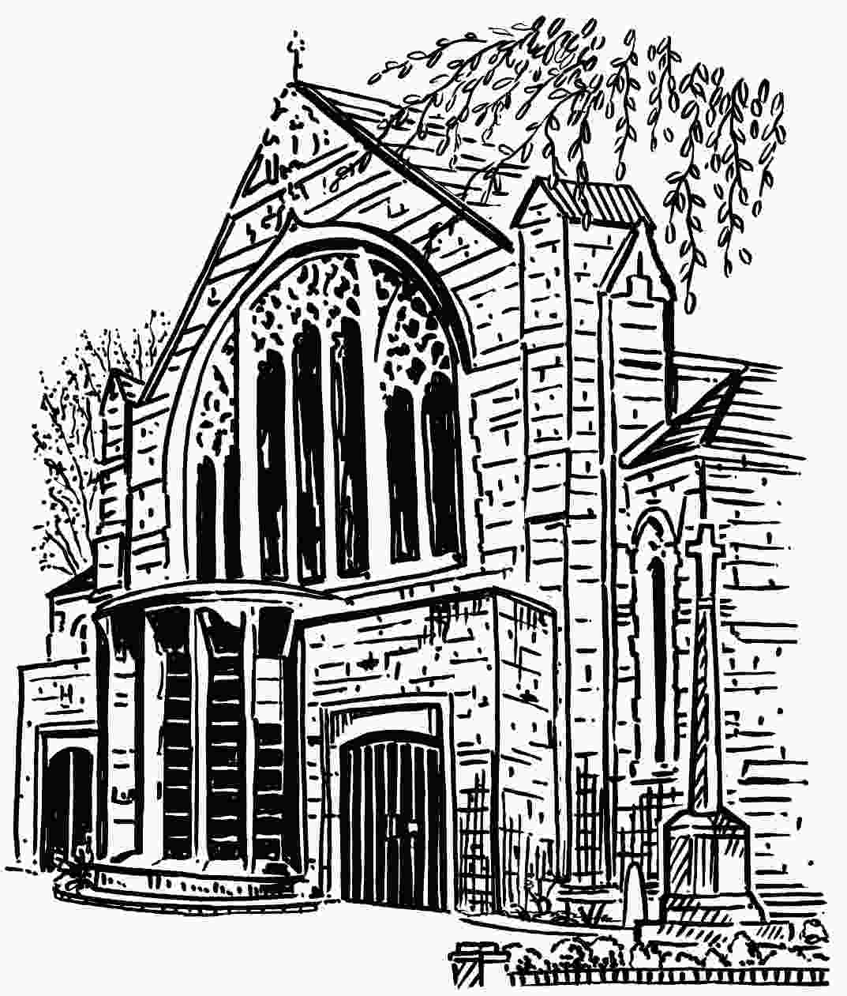
The Parish of St Martin with St Peter

LONE WORKER POLICY

A lone worker is any church member or employee who is alone in the church at any time. This includes all those who are key-holders, and others, including contractors, who may have been given access for specific purposes.
All key -holders shall observe this policy, and are encouraged to avoid situations where they are alone in the church unless it is necessary.
- Anybody with a known medical condition which may put them at particular risk when alone, must not enter the church alone.
- Nobody should enter the church alone before:
    - advising another person or persons that they are doing so, and of the time of entry and the estimated time of exit, and how they may be contacted. (Ideally, this can best be achieved by carrying an active mobile phone at all times while in the church, and exchanging telephone Nos.)
    - ensuring it is safe to enter, and that there are no signs of forced entry.
    - checking that the burglar or fire alarm is not sounding.
- On entering the church and un-setting the burglar alarm, the entry door must be kept closed using the latch lock. If working in the Team Office, ensure the gate at the top of the spiral stairs and the north side Lower Vestry doors are kept locked.
- Whilst working alone, no unknown or unexpected person should be admitted.
- Whilst working alone, no young person or vulnerable adult shall be admitted unless there are two responsible adults present who have been DBS checked.
- Any lone worker must exercise care to avoid accidents, and ensure there is adequate lighting for the activity being undertaken.
They should not undertake any activity which requires working at height, e.g. using a ladder or standing on a chair; using, handling, or lifting equipment or items which would normally require more than one person.
They should also consider how to escape from the church in the event of a fire.
- If the west door is to be left open for public, the key holder should ensure the gate at the top of the spiral stairs and the doors to the Lower Vestry are locked.
- The last key-holder leaving the church must ensure that there is nobody on the premises , and that all exterior doors, the gate at the top of the spiral stairs and the doors to the Lower Vestry doors are locked., Only then should the alarm be re-set and the door locked, outside, using both locks.

Policy adopted by PCC: 14thJuly 2020 . To be reviewed annually V3 15Jul20

