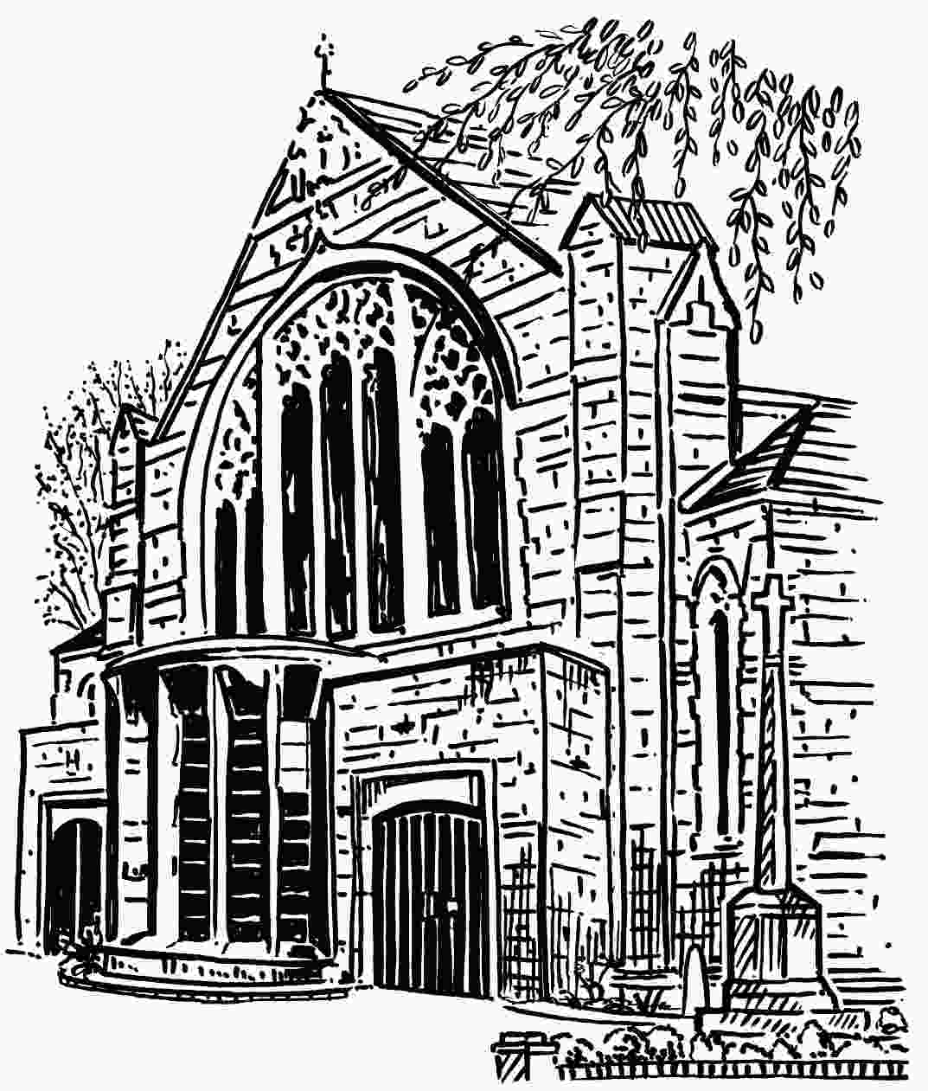
St Martin’s Church

FIRE & EVACUATION PROCEDURE

This procedure is designed to ensure that, in the event of fire or other emergency arising, all persons in any part of the Church are speedily and safely evacuated to the ASSEMBLY AREA (the footpath on London Road in front of the church). The associated Evacuation Plans indicate the locations of the exits, exit signs & routes, fire extinguishers, alarm zones and assembly area, etc.
FIRE EXITS:
- West door (opens out - normal entrance for services and events, permanent exit sign above the door).
- South door (glass doors, opens in - normally locked).
- North east door (downstairs by the boiler room, opens in - normally locked but easy to open from the inside in an emergency, permanent exit sign and simple opening instructions on door).
- South east door (adjacent to the Team Office, opens in – unlocked when church is open, permanent exit sign above door).
When fewer than 25 people are on the premises:
Evacuation shall be through the West door or the South east (office) door, in accordance with the ‘Fire Action Notice’.
For normal services when 100 or less are present:
Evacuation shall be through the West and South doors, and the North east door if necessary. Temporary exit sign to be displayed over the South door.
For services and events when more than 100 people are on the premises, or if it is considered that a significant number are unfamiliar with the layout of the church:
Evacuation shall be through the West, South and North east doors. Temporary exit signs to be displayed over the South door and to indicate the route to the North east door.
Prior to the start of the event, the Fire warden shall make an announcement, identifying the stewards, the exits that are to be used, and explaining the arrangements for evacuation.
FIRE WARDENS & FIRE STEWARDS
The role of Fire warden will be undertaken by Church Wardens, deputy Church Wardens, Verger, Concerts Manager and such other persons as may be necessary for particular events.
The role of Fire steward will generally be undertaken by Sidespersons or others, depending on the type of event.
The Fire warden shall:
- Prior to the service or event, allocate a Fire steward for each exit that is to be used, and further Stewards as necessary to assist with evacuation.
- In the event of an emergency, initiate evacuation by shouting ‘FIRE! FIRE!’
- Call the Emergency Services by calling 999 and ensure they have unimpeded access.
- If safe to do so, investigate the source of, and tackle the fire, without taking risks.
- Only when it is safe to do so, give the ‘all clear’.
- Reset the FIRE ALARM SYSTEM, if it has been activated.
The Fire stewards shall:
- Prior to the service or event, ensure that the exit routes are clear of any obstructions, that the south doors are unlocked, and the temporary exit signs are displayed as necessary.
- On hearing shouts of ‘FIRE! FIRE!’, immediately ensure the exit doors are open.
- Facilitate the evacuation of everybody to the ASSEMBLY AREA, and assist anybody with impaired mobility.
- If safe to do so, ensure there is nobody left in the building.
- Check to ensure there is nobody missing.
- Ensure nobody re-enters the building until the ‘all clear’ is given by the Fire warden.
14July2017

St Martin’s Church

EVACUATION PROCEDURE – Fire Stewards Duties

The role of Fire Steward will generally be undertaken by Sidespersons, or others, depending on the type of event.
The Fire Warden will delegate a Fire Steward (or Stewards) for each exit that is to be used (see below). The door Stewards shall ensure that they can quickly reach their allocated exit if there is an instruction to evacuate. Further Stewards will be delegated as necessary to assist with evacuation (particularly of those with impaired mobility).
Prior to the service or event:
- The Fire Stewards shall ensure that the designated exit routes are clear of any obstructions, the exits are prepared for use, and that the temporary exit signs are displayed as necessary. The temporary exit signs, and the wood bar for the south doors, are kept in the bottom left of the cupboard at the back of the Lady Chapel.
- West Doors - there is a permanent exit sign [EXIT] over the doors to the west porch. Release the floor bolts on both of the doors to the west porch.
- South Doors – secure both doors from the nave into the south porch in the open position using the floor bolts, and, using the metal pole kept behind the radiator in the south porch, place an exit sign [EXIT] into the slot above the doors.
The keys for the glass doors are in the combination keysafe on the wall to the left of the doors. To open, press ‘Clear’; 1 2 3 4; press the top button down and pull the cover towards you. There are two keys – one for the centre and floor locks on the left door, and the other for the floor lock on the right door. Place the wood bar across the top of the door handles to keep the doors in the closed position, and unlock the doors - return the keys to the keysafe.
- North East Doors - there is a permanent exit sign [EXIT] over the inner doors. Secure the inner doors in the open position using the floor bolts, and release the upper bolt on the right outer door. Hang an exit sign [EXIT] on the wallscrew to the left of the archway from the nave, and hang a second exit sign [EXIT] on the wallscrew above the top step of the stairs.
In the event of an instruction to evacuate:
- Fire Stewards will assist the Fire Warden in the speedy and safe evacuation of all persons, in any part of the church, to the Assembly Area (the footpath on London Road in front of the church).
- West Doors - pull open the doors to the west porch and lock in the open position using the floor bolts. Release the two bolts on the left outer door, and secure both doors in the open position using the external cabin hooks. DO NOT deploy the wheelchair ramp – provide assistance to take wheelchairs out backwards down the step. Direct/assist people to the Assembly Area.
- South Doors - lift off the wood bar and pull the doors inwards. Direct/assist people to the Assembly Area.
- North East Doors - release the lower bolt on the right outer door pull the doors inwards. Direct/assist people to the Assembly Area.
- If safe to do so, ensure there is nobody left in the building.
- Check to ensure there is nobody missing.
- Ensure nobody re-enters the building until the ‘all clear’ is given by the Fire warden.
After the service/event:
Fire Stewards shall close/bolt/lock all doors, replace the keys in the keysafe, take down temporary exit signs, and return the signs and wood bar to the cupboard at the back of the Lady Chapel.

17Aug2017

